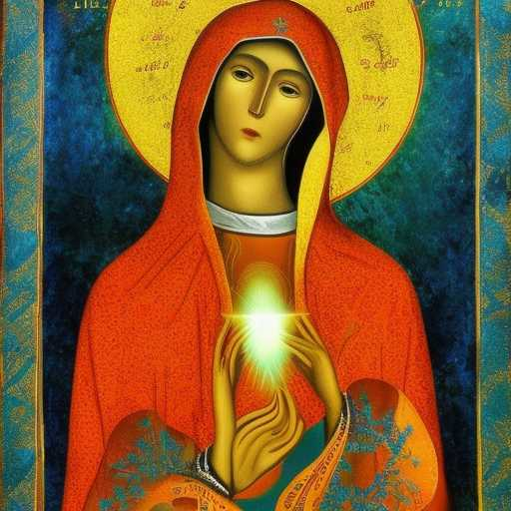
SPARKS OF BLUE & GOLD

My heart is feathered by Da'at, yet grounded by a humbling love
Avila told me of delicious wounds
John toldmme of Living Flames of Love
And I believed
Until She was real to me - an ever blossoming Immaculate
Conception, swirling in streams of light with shimmering sparks of blue and gold

